Rails - Development Process

Different ways to develop a ruby on rails project while keeping good test coverage. Each method defines which tests are required and to what extent they cover edge cases.

# Method 1

## Overview

Test Driven Development (TDD) guided and fully integrated by Behavioural Driven Development (BDD).

## Test Suites

Feature: RSpec w/ Capybara

Request: RSpec

Unit: RSpec

Coverage: Simplecov

## Process

BDD -> TDD method:

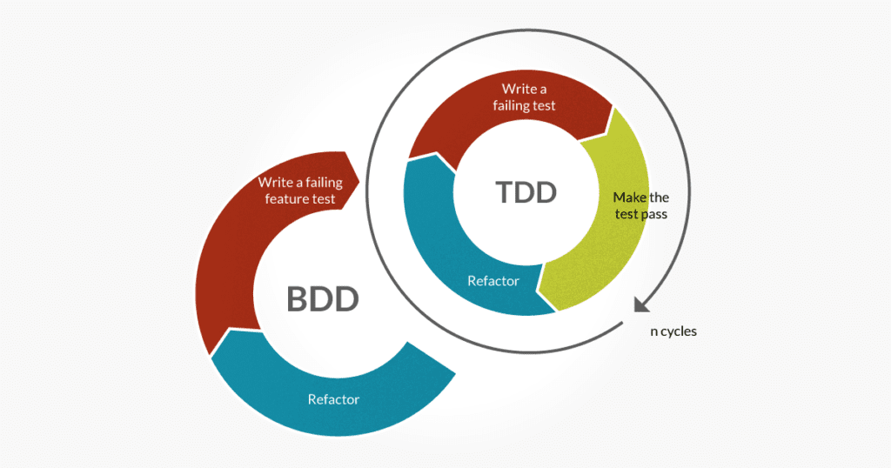

Create feature test step by step for the normal success flow for a user. At each point develop tests for any rails object which is required to fufill the feature test. Unit tests should cover all scenarios, good and bad. Once a feature is built on the backend, styles and javascript are applied to the front-end to enhance user experience.

## Tests required

Feature:

* normal user success flows
* isolate from external services

Requests:

* full requests flows for each route
* includes error handling
* isolate from external and internal services/modules

Model:

* validations
* methods
* class methods
* fully isolated

Views:

* dynamic rendering
* fully isolated

Services:

* full isolated unit test

## Refactoring

Refactoring whenever possible and when required to keep code DRY.

## Comments

* Feature tests often overlap with request specs, however since they simulate a user in a real browser they provide integration testing for the entire app